1992 年 AMC 8 真题与解答
American Mathematics Competitions 8 · 中英双语
共 25 题，限时 40 分钟；单项选择题，每题 1 分，答错不扣分，满分 25 分。
内容来源：LIVE by Po-Shen Loh（live.poshenloh.com）历年 AMC 8 真题与解答，试题经美国数学协会（MAA）官方授权使用；本文档由本地整理生成，供个人学习使用，版权归原作者及 MAA 所有。
编排说明：第一部分为题目（先中文、后英文原题），第二部分为解答与答案，便于先做题后对答案。
第一部分 题目
第 1 题
下列表达式的值是多少？
scriptsize (10 - 9 + 8 - 7 + 6 - 5 + 4 - 3 + 2 - 1)/(1 - 2 + 3 - 4 + 5 - 6 + 7 - 8 + 9)
（A）-1 （B）1 （C）5 （D）9 （E）10
English
What is the value of the following expression?
scriptsize (10 - 9 + 8 - 7 + 6 - 5 + 4 - 3 + 2 - 1)/(1 - 2 + 3 - 4 + 5 - 6 + 7 - 8 + 9)
(A) -1 (B) 1 (C) 5 (D) 9 (E) 10
第 2 题
下列哪一个不等于 5/4？
（A）10/8 （B）11/4 （C）13/12 （D）11/5 （E）110/40
English
Which of the following is <b>not</b> equal to 5/4?
(A) 10/8 (B) 11/4 (C) 13/12 (D) 11/5 (E) 110/40
第 3 题
从集合 {-16, -4, 0, 2, 4, 12} 中选两个数相减，能够得到的最大差是多少？
（A）10 （B）12 （C）16 （D）28 （E）48
English
What is the largest difference that can be formed by subtracting two numbers chosen from the set {-16, -4, 0, 2, 4, 12}?
(A) 10 (B) 12 (C) 16 (D) 28 (E) 48
第 4 题
在垒球赛季中，Judy 有 35 次安打。其中包括 1 次本垒打、1 次三垒安打和 5 次二垒安打。其余安打都是一垒安打。她的安打中有百分之几是一垒安打？
（A）28% （B）35% （C）70% （D）75% （E）80%
English
During the softball season, Judy had 35 hits. Among her hits were 1 home run, 1 triple, and 5 doubles. The rest of her hits were singles. What percent of her hits were singles?
(A) 28% (B) 35% (C) 70% (D) 75% (E) 80%
第 5 题
如图，一个直径为 1 的圆被从 2 × 3 的长方形中去掉。阴影区域的面积最接近哪个整数？

（A）1 （B）2 （C）3 （D）4 （E）5
English
A circle of diameter 1 is removed from a 2 × 3 rectangle, as shown. Which whole number is closest to the area of the shaded region?
(A) 1 (B) 2 (C) 3 (D) 4 (E) 5
第 6 题
如下图所示，一个上方数为 a、左下方数为 b、右下方数为 c 的三角表达式表示 a+b-c。图中所示的和是多少？
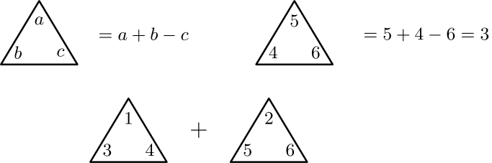
（A）-2 （B）-1 （C）0 （D）1 （E）2
English
A triangular expression with top entry a, lower-left entry b, and lower-right entry c means a+b-c, as shown below. What is the indicated sum?
(A) -2 (B) -1 (C) 0 (D) 1 (E) 2
第 7 题
998 的数位和是 9 + 9 + 8 = 26。有多少个 3 位整数的数位和为 26，且是偶数？
（A）1 （B）2 （C）3 （D）4 （E）5
English
The digit-sum of 998 is 9 + 9 + 8 = 26. How many 3-digit whole numbers, whose digit-sum is 26, are even?
(A) 1 (B) 2 (C) 3 (D) 4 (E) 5
第 8 题
一位店主买入 1500 支铅笔，每支价格为 $0.10。如果他以每支 $0.25 出售，那么他必须卖出多少支，才能恰好获利 $100.00？
（A）400 （B）667 （C）1000 （D）1500 （E）1900
English
A store owner bought 1500 pencils at $0.10 each. If he sells them for $0.25 each, how many of them must he sell to make a profit of exactly $100.00?
(A) 400 (B) 667 (C) 1000 (D) 1500 (E) 1900
第 9 题
一个小镇的人口是 480。图中表示该镇女性和男性的人数，但省略了纵轴的刻度值。标有 F 和 M 的柱分别表示女性和男性。这个小镇有多少名男性？
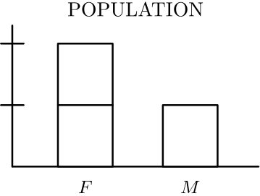
（A）120 （B）160 （C）200 （D）240 （E）360
English
The population of a small town is 480. The graph indicates the numbers of females and males in the town, but the vertical scale values are omitted. The bars labeled F and M represent females and males, respectively. How many males live in the town?
(A) 120 (B) 160 (C) 200 (D) 240 (E) 360
第 10 题
一个直角边长均为 8 的等腰直角三角形，如图被分成 16 个全等三角形。阴影部分面积是
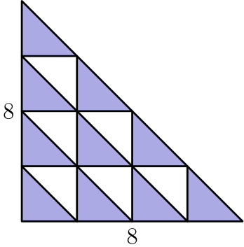
（A）10 （B）20 （C）32 （D）40 （E）64
English
An isosceles right triangle with legs of length 8 is partitioned into 16 congruent triangles as shown. The shaded area is
(A) 10 (B) 20 (C) 32 (D) 40 (E) 64
第 11 题
条形图显示了一项颜色偏好调查的结果。各柱从左到右依次表示红、蓝、棕、粉、绿。偏好蓝色的人占百分之几？
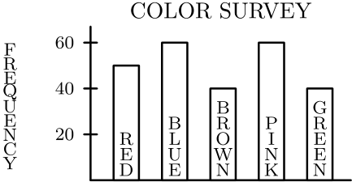
（A）20% （B）24% （C）30% （D）36% （E）42%
English
The bar graph shows the results of a survey on color preferences. From left to right, the bars represent red, blue, brown, pink, and green. What percent preferred blue?
(A) 20% (B) 24% (C) 30% (D) 36% (E) 42%
第 12 题
一辆车的五个轮胎（四个行驶轮胎和一个全尺寸备胎）进行轮换，使得汽车行驶前 30,000 英里期间每个轮胎使用的里程数相同。每个轮胎使用了多少英里？
（A）6000 （B）7500 （C）24,000 （D）30,000 （E）37,500
English
The five tires of a car (four road tires and a full-sized spare) were rotated so that each tire was used the same number of miles during the first 30,000 miles the car traveled. For how many miles was each tire used?
(A) 6000 (B) 7500 (C) 24,000 (D) 30,000 (E) 37,500
第 13 题
五个考试分数的平均数是 90，中位数是 91，众数是 94。最低的两个考试分数之和是
（A）170 （B）171 （C）176 （D）177 （E）由已给信息无法确定
English
Five test scores have a mean (average score) of 90, a median (middle score) of 91, and a mode (most frequent score) of 94. The sum of the two lowest test scores is
(A) 170 (B) 171 (C) 176 (D) 177 (E) not determined by the information given
第 14 题
向一个已装满三分之一的水箱中加入四加仑水后，水箱变为装满一半。这个水箱的容量是多少加仑？
（A）8 （B）12 （C）20 （D）24 （E）48
English
When four gallons are added to a tank that is one-third full, the tank is then one-half full. The capacity of the tank in gallons is
(A) 8 (B) 12 (C) 20 (D) 24 (E) 48
第 15 题
这个序列中的第 1992 个字母是什么？
ABCDEDCBAABCDEDCBAABCDEDCBAABCDEDC⋯
（A）A （B）B （C）C （D）D （E）E
English
What is the 1992nd letter in this sequence?
ABCDEDCBAABCDEDCBAABCDEDCBAABCDEDC⋯
(A) A (B) B (C) C (D) D (E) E
第 16 题
哪个圆柱体的体积是右图所示圆柱体体积的两倍？
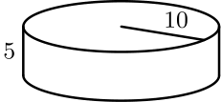
（A）<img src="/amc8/1992/16a.svg" style="max-height:6rem;max-width:8rem"/> （B）<img src="/amc8/1992/16b.svg" style="max-height:6rem;max-width:8rem"/> （C）<img src="/amc8/1992/16c.svg" style="max-height:6rem;max-width:8rem"/> （D）<img src="/amc8/1992/16d.svg" style="max-height:6rem;max-width:8rem"/> （E）以上都不是
English
Which cylinder has twice the volume of the cylinder shown at right?
(A) <img src="/amc8/1992/16a.svg" style="max-height:6rem;max-width:8rem"/> (B) <img src="/amc8/1992/16b.svg" style="max-height:6rem;max-width:8rem"/> (C) <img src="/amc8/1992/16c.svg" style="max-height:6rem;max-width:8rem"/> (D) <img src="/amc8/1992/16d.svg" style="max-height:6rem;max-width:8rem"/> (E) None of the above
第 17 题
一个三角形的边长为 6.5、10 和 s，其中 s 是整数。s 的最小可能值是多少？
（A）3 （B）4 （C）5 （D）6 （E）7
English
The sides of a triangle have lengths 6.5, 10, and s, where s is a whole number. What is the smallest possible value of s?
(A) 3 (B) 4 (C) 5 (D) 6 (E) 7
第 18 题
一辆车旅行时，先在一个半小时内行驶 80 英里，然后在交通堵塞中停了 30 分钟，接着行驶 100 英里，用时 2 小时。这辆车在整个 4 小时旅程中的平均速度是多少英里每小时？
（A）45 （B）50 （C）60 （D）75 （E）90
English
On a trip, a car traveled 80 miles in an hour and a half, then was stopped in traffic for 30 minutes, then traveled 100 miles during the next 2 hours. What was the car’s average speed in miles per hour for the 4-hour trip?
(A) 45 (B) 50 (C) 60 (D) 75 (E) 90
第 19 题
一条州际公路上第 5 个出口和第 26 个出口之间的距离是 118 英里。如果任意两个出口之间至少相距 5 英里，那么在第 5 个和第 26 个出口之间，相邻两个出口之间最多可以相距多少英里？
（A）8 （B）13 （C）18 （D）47 （E）98
English
The distance between the 5th and 26th exits on an interstate highway is 118 miles. If any two exits are at least 5 miles apart, then what is the largest number of miles there can be between two consecutive exits that are between the 5th and 26th exits?
(A) 8 (B) 13 (C) 18 (D) 47 (E) 98
第 20 题
下列哪一种由全等正方形组成的图案，不能沿所示线折成一个立方体？
（A）<img src="/amc8/1992/20a.svg" style="max-height:4rem;max-width:6rem"/> （B）<img src="/amc8/1992/20b.svg" style="max-height:4rem;max-width:6rem"/> （C）<img src="/amc8/1992/20c.svg" style="max-height:4rem;max-width:6rem"/> （D）<img src="/amc8/1992/20d.svg" style="max-height:4rem;max-width:6rem"/> （E）<img src="/amc8/1992/20e.svg" style="max-height:4rem;max-width:6rem"/>
English
Which pattern of identical squares could <b>not</b> be folded along the lines shown to form a cube?
(A) <img src="/amc8/1992/20a.svg" style="max-height:4rem;max-width:6rem"/> (B) <img src="/amc8/1992/20b.svg" style="max-height:4rem;max-width:6rem"/> (C) <img src="/amc8/1992/20c.svg" style="max-height:4rem;max-width:6rem"/> (D) <img src="/amc8/1992/20d.svg" style="max-height:4rem;max-width:6rem"/> (E) <img src="/amc8/1992/20e.svg" style="max-height:4rem;max-width:6rem"/>
第 21 题
Northside 的鼓号队为旅行筹款。鼓手和号手分别记录销售额。图中每组的空心柱表示鼓手，阴影柱表示号手。根据下面的双条形图，哪个月份中一个小组的销售额超过另一个小组的百分比最大？
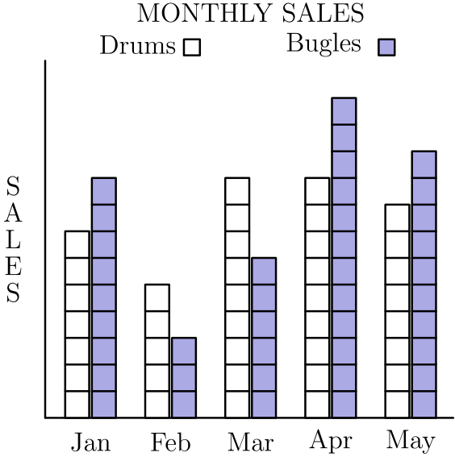
（A）一月 （B）二月 （C）三月 （D）四月 （E）五月
English
Northside’s Drum and Bugle Corps raised money for a trip. The drummers and bugle players kept separate sales records. In each pair on the graph, the open bar represents drums and the shaded bar represents bugles. According to the double bar graph of monthly sales below, in what month did one group’s sales exceed the other’s by the greatest percent?
(A) Jan (B) Feb (C) Mar (D) Apr (E) May
第 22 题
如图，八块 1 × 1 的正方形瓷砖拼成一个图形，其外边界周长为 14 个单位。再加入两块同样大小的瓷砖，使每块新增瓷砖至少有一条边与原图中某个正方形的一条边重合。下列哪一个可能是新图形的周长？
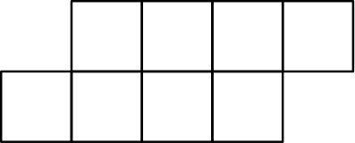
（A）15 （B）17 （C）18 （D）19 （E）20
English
Eight 1 × 1 square tiles are arranged as shown so their outside edges form a polygon with a perimeter of 14 units. Two additional tiles of the same size are added to the figure so that at least one side of each added tile is shared with a side of one of the squares in the original figure. Which of the following could be the perimeter of the new figure?
(A) 15 (B) 17 (C) 18 (D) 19 (E) 20
第 23 题
掷两颗骰子，朝上点数的乘积大于 10 的概率是
（A）3/7 （B）17/36 （C）1/2 （D）5/8 （E）11/12
English
If two dice are tossed, the probability that the product of the numbers showing on the tops of the dice is greater than 10 is
(A) 3/7 (B) 17/36 (C) 1/2 (D) 5/8 (E) 11/12
第 24 题
如图排列四个半径为 3 的圆，它们的圆心是一个正方形的四个顶点。阴影区域的面积最接近
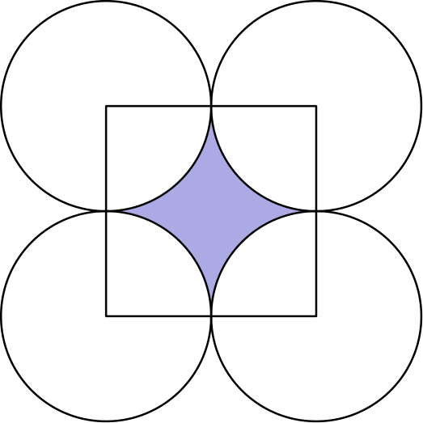
（A）7.7 （B）12.1 （C）17.2 （D）18 （E）27
English
Four circles of radius 3 are arranged as shown. Their centers are the vertices of a square. The area of the shaded region is closest to
(A) 7.7 (B) 12.1 (C) 17.2 (D) 18 (E) 27
第 25 题
一个装满水的容器先倒出其中的一半。然后倒出剩余水的三分之一。继续这个过程：第三次倒出剩余水的四分之一，第四次倒出剩余水的五分之一，依此类推。倒多少次后，正好剩下原来水量的十分之一？
（A）6 （B）7 （C）8 （D）9 （E）10
English
One half of the water is poured out of a full container. Then one third of the remainder is poured out. Continue the process: one fourth of the remainder for the third pouring, one fifth of the remainder for the fourth pouring, and so on. After how many pourings does exactly one tenth of the original water remain?
(A) 6 (B) 7 (C) 8 (D) 9 (E) 10

第二部分 解答
答案速查：
题号 1 2 3 4 5 6 7 8 9
答案 B D D E E D A C B
题号 10 11 12 13 14 15 16 17 18
答案 B B C B D C B B A
题号 19 20 21 22 23 24 25
答案 C D B C B A D
答案串：BDDEEDACBBBCBDCBBACDBCBAD
第 1 题 答案 B
分子两两分组得 (10-9) + (8-7) + (6-5) + (4-3) + (2-1) = 5。
分母分组为 (1-2) + (3-4) + (5-6) + (7-8) + 9，有四组 -1，再加 9，结果也是 5。
所以原式为 5/5 = 1。
所以正确答案是 <b>B</b>。
English
Grouping the numerator in pairs gives (10-9) + (8-7) + (6-5) + (4-3) + (2-1) = 5.
Grouping the denominator as (1-2) + (3-4) + (5-6) + (7-8) + 9 gives four pairs of -1 plus 9, which is 5.
So the expression is 5/5 = 1.
Thus, the correct answer is <b>B</b>.
第 2 题 答案 D
5/4 = 11/4。逐项检查：10/8 = 5/4，11/4 = 5/4，13/12 = 11/4 = 5/4，且 110/40 = 11/4 = 5/4。
但 11/5 = 6/5 ≠ 5/4。
所以正确答案是 <b>D</b>。
English
Note 5/4 = 11/4. Now check each choice: 10/8 = 5/4, 11/4 = 5/4, 13/12 = 11/4 = 5/4, and 110/40 = 11/4 = 5/4.
But 11/5 = 6/5 ≠ 5/4.
Thus, the correct answer is <b>D</b>.
第 3 题 答案 D
最大差应使用最大数 12 减去最小数 -16。
这给出 12 - (-16) = 28。
所以正确答案是 <b>D</b>。
English
The largest difference uses the largest number, 12, minus the smallest number, -16.
This gives 12 - (-16) = 28.
Thus, the correct answer is <b>D</b>.
第 4 题 答案 E
非一垒安打共有 1 + 1 + 5 = 7 次，所以一垒安打有 35 - 7 = 28 次。
一垒安打所占比例为 28/35 = 4/5 = 80%。
所以正确答案是 <b>E</b>。
English
The non-single hits number 1 + 1 + 5 = 7, so the singles number 35 - 7 = 28.
The fraction of singles is 28/35 = 4/5 = 80%.
Thus, the correct answer is <b>E</b>.
第 5 题 答案 E
长方形面积为 6，去掉的圆面积为 π(1/2)² = π/4 ≈ 0.79。
阴影区域面积约为 6 - 0.79 ≈ 5.2，最接近的整数是 5。
所以正确答案是 <b>E</b>。
English
The rectangle has area 6, and the removed circle has area π(1/2)² = π/4 ≈ 0.79.
So the shaded region has area 6 - 0.79 ≈ 5.2, whose closest whole number is 5.
Thus, the correct answer is <b>E</b>.
第 6 题 答案 D
第一组三个数给出 1 + 3 - 4 = 0，第二组三个数给出 2 + 5 - 6 = 1。
它们的和是 0 + 1 = 1。
所以正确答案是 <b>D</b>。
English
The first triple gives 1 + 3 - 4 = 0, and the second gives 2 + 5 - 6 = 1.
Their sum is 0 + 1 = 1.
Thus, the correct answer is <b>D</b>.
第 7 题 答案 A
三个数字的和为 26，只能是数字 9、9、8。由它们组成的 3 位数是 899、989 和 998。
其中只有 998 是偶数，所以这样的数恰好有 1 个。
所以正确答案是 <b>A</b>。
English
A digit-sum of 26 with three digits requires the digits 9, 9, and 8. The 3-digit numbers using them are 899, 989, and 998.
Of these, only 998 is even, so there is exactly 1 such number.
Thus, the correct answer is <b>A</b>.
第 8 题 答案 C
铅笔成本为 1500 × $0.10 = $150。要获利 $100，收入必须是 $150 + $100 = $250。
每支售价 $0.25，所以必须卖出 ($250)/($0.25) = 1000 支。
所以正确答案是 <b>C</b>。
English
The pencils cost 1500 × $0.10 = $150. To make a $100 profit, the revenue must be $150 + $100 = $250.
At $0.25 each, he must sell ($250)/($0.25) = 1000 pencils.
Thus, the correct answer is <b>C</b>.
第 9 题 答案 B
若男性人数为 M，则女性人数为 2M，总人口满足 M + 2M = 480。
所以 3M = 480，得到 M = 160。
所以正确答案是 <b>B</b>。
English
If there are M males, then there are 2M females, and together M + 2M = 480.
So 3M = 480, giving M = 160.
Thus, the correct answer is <b>B</b>.
第 10 题 答案 B
大三角形面积为 1/2 × 8 × 8 = 32，所以 16 个全等小三角形中每个面积为 32/16 = 2。
图中有十个小三角形被涂色，所以阴影面积是 10 × 2 = 20。
所以正确答案是 <b>B</b>。
English
The large triangle has area 1/2 × 8 × 8 = 32, so each of the 16 congruent small triangles has area 32/16 = 2.
Ten of the small triangles are shaded, so the shaded area is 10 × 2 = 20.
Thus, the correct answer is <b>B</b>.
第 11 题 答案 B
调查总人数是 50 + 60 + 40 + 60 + 40 = 250。
偏好蓝色的比例为 60/250 = 24%。
所以正确答案是 <b>B</b>。
English
The total number surveyed is 50 + 60 + 40 + 60 + 40 = 250.
The percent preferring blue is 60/250 = 24%.
Thus, the correct answer is <b>B</b>.
第 12 题 答案 C
在 30,000 英里的行驶中，始终有 4 个轮胎在使用，所以总轮胎里程为 4 × 30,000 = 120,000 轮胎英里。
平均分给 5 个轮胎，每个轮胎使用 (120,000)/5 = 24,000 英里。
所以正确答案是 <b>C</b>。
English
During the 30,000 miles, 4 tires are always in use, so the total tire-mileage is 4 × 30,000 = 120,000 tire-miles.
Split equally among 5 tires, each tire is used (120,000)/5 = 24,000 miles.
Thus, the correct answer is <b>C</b>.
第 13 题 答案 B
五个分数总和为 5 × 90 = 450。中位数是第三个分数 91。因为 94 是众数，它至少出现两次，且这两次都在中位数以上，所以最高两个分数分别是 94 和 94。
三个最高分是 91、94、94，和为 279。因此最低两个分数之和是 450 - 279 = 171。
所以正确答案是 <b>B</b>。
English
The five scores sum to 5 × 90 = 450. The median is the third score, 91. Since 94 is the mode, it must appear at least twice, and both copies lie above the median, so the two highest scores are 94 and 94.
The three highest scores are 91, 94, and 94, summing to 279. So the two lowest sum to 450 - 279 = 171.
Thus, the correct answer is <b>B</b>.
第 14 题 答案 D
加入的 4 加仑对应从 1/3 满到 1/2 满的增加量，即容量的 1/2 - 1/3 = 1/6。
如果容量的 1/6 是 4 加仑，那么总容量是 4 × 6 = 24 加仑。
所以正确答案是 <b>D</b>。
English
The 4 gallons account for the change from 1/3 full to 1/2 full, which is 1/2 - 1/3 = 1/6 of the capacity.
If 1/6 of the capacity is 4 gallons, the full capacity is 4 × 6 = 24 gallons.
Thus, the correct answer is <b>D</b>.
第 15 题 答案 C
这个序列是 9 个字母的循环块 ABCDEDCBA 不断重复。
因为 1992 = 9 × 221 + 3，所以第 1992 个字母是一个循环块中的第 3 个字母，即 C。
所以正确答案是 <b>C</b>。
English
The sequence is the 9-letter block ABCDEDCBA repeated again and again.
Since 1992 = 9 × 221 + 3, the 1992nd letter is the 3rd letter of a block, which is C.
Thus, the correct answer is <b>C</b>.
第 16 题 答案 B
给定圆柱体的体积是 π × 10² × 5 = 500π，所以两倍体积是 1000π。
各选项体积为：A 是 π × 20² × 5 = 2000π，B 是 π × 10² × 10 = 1000π，C 是 π × 5² × 20 = 500π，D 是 π × 20² × 10 = 4000π。只有 B 等于 1000π。
所以正确答案是 <b>B</b>。
English
The given cylinder has volume π × 10² × 5 = 500π, so a cylinder of twice the volume has volume 1000π.
The choices have volumes π × 20² × 5 = 2000π (A), π × 10² × 10 = 1000π (B), π × 5² × 20 = 500π (C), and π × 20² × 10 = 4000π (D). Only (B) equals 1000π.
Thus, the correct answer is <b>B</b>.
第 17 题 答案 B
由三角形不等式，6.5 + s 必须大于最长边 10，所以 s > 3.5。
大于 3.5 的最小整数是 4，而它确实能组成三角形。
所以正确答案是 <b>B</b>。
English
By the triangle inequality, 6.5 + s must exceed the longest side 10, so s > 3.5.
The smallest whole number greater than 3.5 is 4, and it does form a valid triangle.
Thus, the correct answer is <b>B</b>.
第 18 题 答案 A
这辆车总共行驶 80 + 100 = 180 英里，总时间为 1.5 + 0.5 + 2 = 4 小时，其中堵车停止时间也计入。
平均速度为 180/4 = 45 英里每小时。
所以正确答案是 <b>A</b>。
English
The car covered 80 + 100 = 180 miles in total, over 1.5 + 0.5 + 2 = 4 hours (the traffic stop still counts as time).
The average speed is 180/4 = 45 miles per hour.
Thus, the correct answer is <b>A</b>.
第 19 题 答案 C
从第 5 个出口到第 26 个出口，共有 26 - 5 = 21 个相邻出口间隔，每个至少 5 英里。
要最大化其中一个间隔，就让其他 20 个间隔都等于 5 英里，共占 20 × 5 = 100 英里。剩下的间隔是 118 - 100 = 18 英里。
所以正确答案是 <b>C</b>。
English
From the 5th exit to the 26th exit there are 26 - 5 = 21 gaps between consecutive exits, each at least 5 miles.
To maximize one gap, make the other 20 gaps exactly 5 miles, using 20 × 5 = 100 miles. The remaining gap is 118 - 100 = 18 miles.
Thus, the correct answer is <b>C</b>.
第 20 题 答案 D
五个图案都由 6 个正方形组成。把 A、B、C 和 E 折叠时，各正方形能分别覆盖立方体的六个面。
对图案 D，无论怎样折叠，都会迫使两个正方形落在同一个面上而重叠，所以不能形成立方体。
所以正确答案是 <b>D</b>。
English
Each of the five patterns has 6 squares. Folding patterns (A), (B), (C), and (E) wraps the squares neatly onto the six faces of a cube.
For pattern (D), any attempt to fold forces two of the squares to land on the same face, so they overlap and no cube can be formed.
Thus, the correct answer is <b>D</b>.
第 21 题 答案 B
从图上读出（鼓手，号手）的销售额：一月 (7, 9)，二月 (5, 3)，三月 (9, 6)，四月 (9, 12)，五月 (8, 10)。
较大值超过较小值的百分比分别为：一月 2/7 ≈ 29%，二月 2/3 ≈ 67%，三月 3/6 = 50%，四月 3/9 ≈ 33%，五月 2/8 = 25%。最大的是二月，此时 5 比 3 大约 67%。
所以正确答案是 <b>B</b>。
English
Reading the graph gives (drums, bugles): January (7, 9), February (5, 3), March (9, 6), April (9, 12), and May (8, 10).
The percent excess of the larger over the smaller is 2/7 ≈ 29% in January, 2/3 ≈ 67% in February, 3/6 = 50% in March, 3/9 ≈ 33% in April, and 2/8 = 25% in May. The greatest is February, where 5 exceeds 3 by about 67%.
Thus, the correct answer is <b>B</b>.
第 22 题 答案 C
一块只共享一条边的新增瓷砖会使周长增加 2：四条新边中有两条因共享边而不在外边界上。若共享两条边，则周长增加 0。
加入两块瓷砖后，周长可能增加 0、2 或 4，新周长可能为 14、16 或 18。选项中只有 18 可能。
所以正确答案是 <b>C</b>。
English
A tile that shares exactly one side adds 2 to the perimeter (four new edges minus two hidden), while a tile sharing two sides adds 0.
With two added tiles the perimeter can change by 0, 2, or 4, giving new perimeters of 14, 16, or 18. Of the choices, only 18 is possible.
Thus, the correct answer is <b>C</b>.
第 23 题 答案 B
共有 36 个等可能结果。按第一颗骰子的点数，计算乘积大于 10 的有序数对：若为 2，有 1 个结果满足，即 2 × 6；若为 3，有 3 个；若为 4，有 4 个；若为 5，有 4 个；若为 6，有 5 个。
有利结果总数为 1 + 3 + 4 + 4 + 5 = 17，所以概率是 17/36。
所以正确答案是 <b>B</b>。
English
There are 36 equally likely outcomes. Counting the ordered pairs whose product exceeds 10: with a first die of 2 there is 1 (namely 2 × 6); of 3, there are 3; of 4, there are 4; of 5, there are 4; of 6, there are 5.
That is 1 + 3 + 4 + 4 + 5 = 17 favorable outcomes, so the probability is 17/36.
Thus, the correct answer is <b>B</b>.
第 24 题 答案 A
相邻圆相切，所以圆心组成的正方形边长为 2 × 3 = 6，面积为 36。
在正方形内，每个圆贡献一个四分之一圆，四个四分之一圆合成一个完整圆，面积为 9π ≈ 28.3。阴影面积为 36 - 9π ≈ 7.7。
所以正确答案是 <b>A</b>。
English
Because adjacent circles are tangent, the square through the centers has side 2 × 3 = 6 and area 36.
Inside the square, each circle contributes a quarter-circle, and the four quarters make one full circle of area 9π ≈ 28.3. The shaded region is 36 - 9π ≈ 7.7.
Thus, the correct answer is <b>A</b>.
第 25 题 答案 D
第 n 次倒出后，剩余比例为 1/2 × 2/3 × 3/4 × ⋯ × n/n+1，逐项约分后等于 1/n+1。
令 1/n+1 = 1/10，得到 n = 9。
所以正确答案是 <b>D</b>。
English
After the nth pouring, the fraction remaining is 1/2 × 2/3 × 3/4 × ⋯ × n/n+1, which telescopes to 1/n+1.
Setting 1/n+1 = 1/10 gives n = 9.
Thus, the correct answer is <b>D</b>.

